As a HR manager and admin of this system I want to be able to see the password of the employee in order to
Here in the employee page when I want to add an employee under the HR manager I cant as it is not
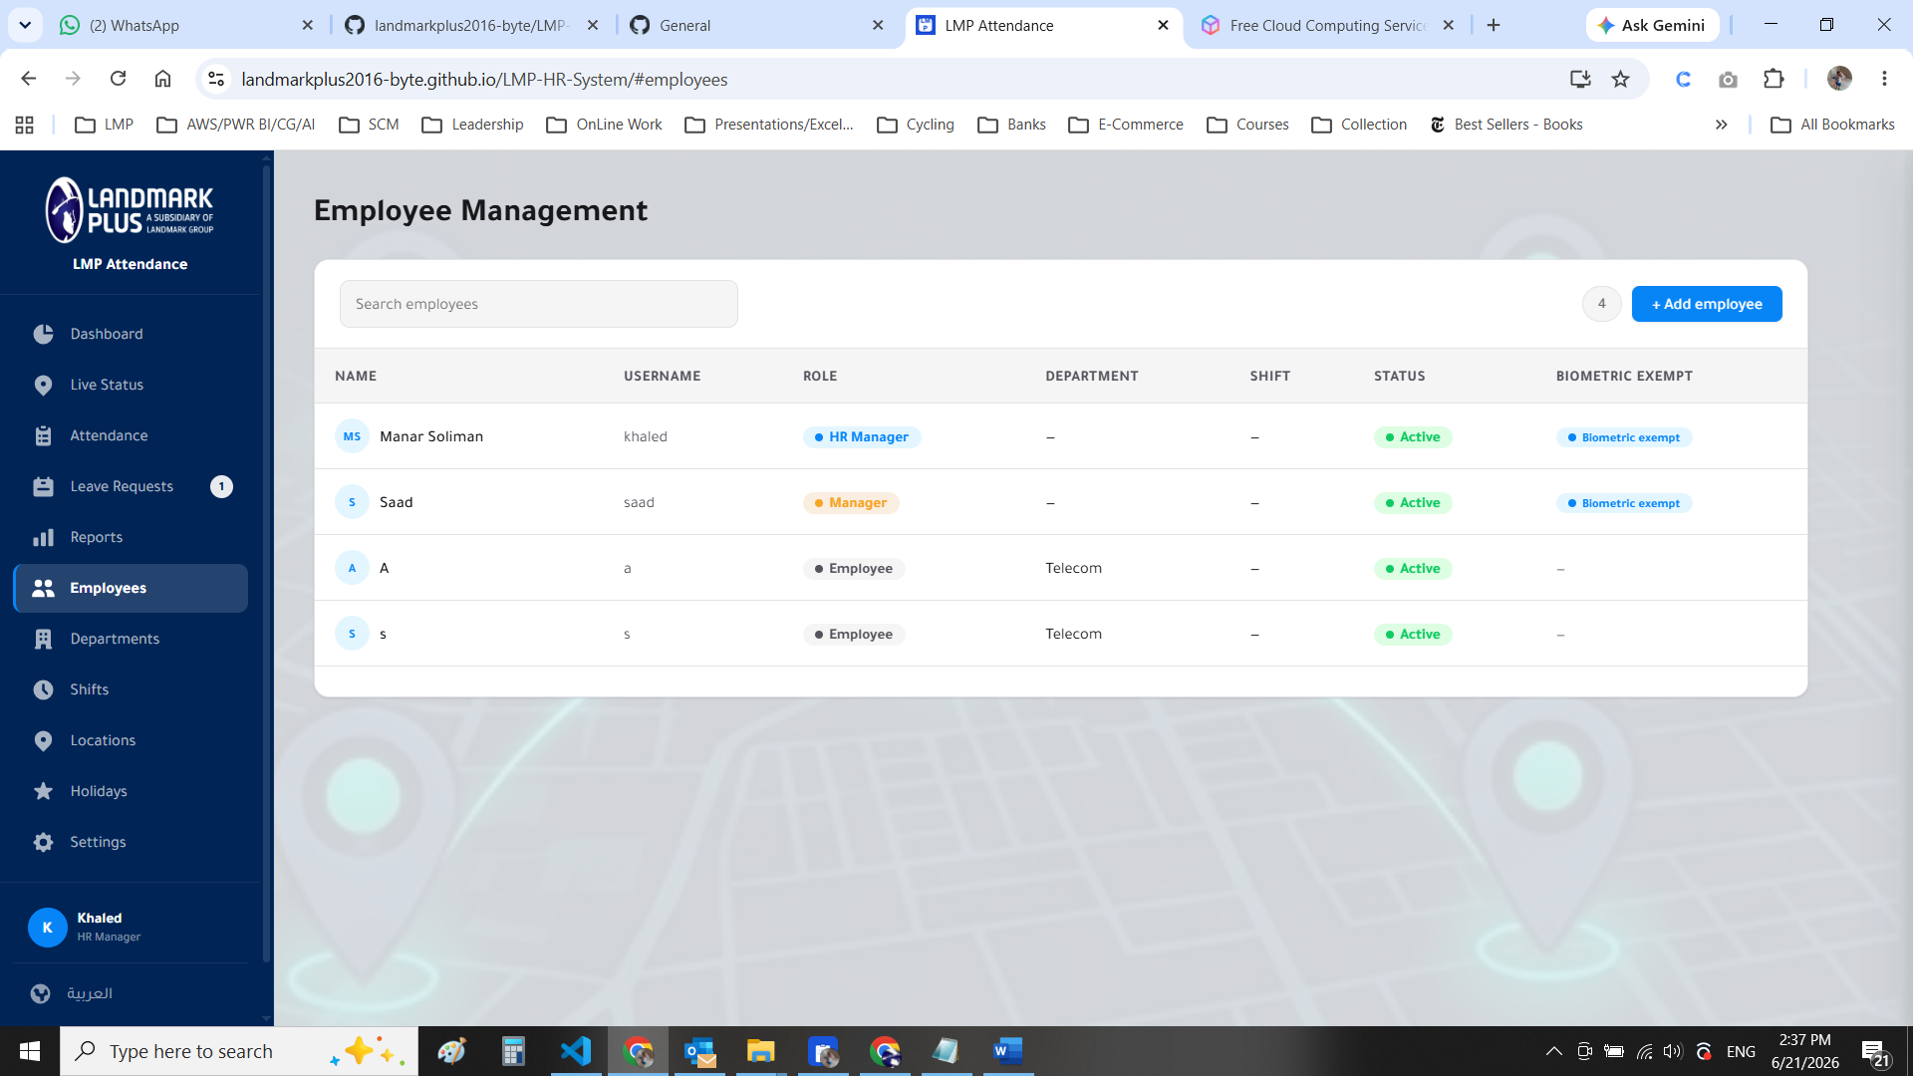

How is the hr manager going to see the employees uder him from the mobile when the hr department employees try to login or request leaves please explain it
*
when hovering on the cards the glow background appears but the popup of the card is not working

I have created new manager and employee under him when the employee checks in the hr manager can see it from the application but the manager sees him as absent

Now I want you to check the login check in process as for now I can use the same user pass with multiple mobile phone and this is not correct as each employee need to check in himself not another college checking in for him

Now the vacation balance is not calculated that it is not deducting the approved vacations of the employee I want to fix this issue

Should there be an attendance to the managers or not, please check the current status

